|  |  |  |  |
| --- | --- | --- | --- |
| D:\Rinat\Rinat\доки\журнал\статьи\logo.jpg | EFFECT OF ZINC PHOSPHATE ON THE FORMATION OF COATINGS FROM a POLYVINyL ACETATE DISPERSION | | |
| Cite this: *INEOS OPEN*,  **2025**, *8 (1–3)*, 108–109  DOI: 10.32931/io2552a  *Received 25 November 2024,*  *Accepted 15 February 2025*  http://ineosopen.org | | S. V. Vargasova and A. E. Tereshko | |
| Yaroslavl State Technical University, Moskovskii pr. 88, Yaroslavl, 150023 Russia | |
| Abstract  The effect of zinc phosphate on the properties of aqueous dispersion materials during storage and coating formation is shown. It is established that the water-soluble salts being present in the composition of zinc phosphate can have a negative effect on the aggregate stability of the aqueous dispersion of polyvinyl acetate, leading to the accumulation of coagulum during the material storage. | | | C:\Users\79101\Desktop\Без имени.png |
| **Key words:** dispersion of polyvinyl acetate, zinc phosphate, aggregate stability, surface energy, optical density. | | | |

**Introduction**

Due to stricter environmental requirements, organo-diluted paint and varnish materials are replaced with water-dispersion. At the same time, effective anticorrosive materials contain chromates and heavy metal ions in their compositions, which negatively affect human health and the environment. The development of an aqueous dispersion material with a non-toxic anticorrosive agent could solve the entire range of problems that arise [1–3]. Zinc phosphate can be used as a non-toxic anticorrosive pigment. Since a combination of aqueous dispersions of polymers with other components can affect their aggregative and sedimentation stability, it is necessary to investigate the effect of zinc phosphate on the stability of polymer dispersions. In addition, various manufacturers produce zinc phosphate, which differs in properties: pH of the aqueous extract, dispersion, *etc*.

Results and discussion

The research objects were the aqueous dispersion of polyvinyl acetate (PVA DT 45/10 B STO 12174656-003-2014) and zinc phosphate samples with different acidity (Table 1).

To evaluate the effect of zinc phosphate on the aggregate stability and properties of the coatings formed from the PVA dispersion, the surface energy of the resulting coatings was studied (Fig. 1). The dispersion of PVA was combined with the aqueous extract of zinc phosphate. A reference sample was the dispersion of PVA combined with distilled water. The coatings were formed at different exposure times of the resulting systems. It was found that there is a change in the surface energy, which is caused to a greater extent by an increase in the polar component after 10 days of exposure, indicating the redistribution of the surfactant in the system that stabilizes the dispersion. After that, the value of the surface energy decreases.

The effect of zinc phosphate on the aggregate stability of the

**Table 1.** Properties of the zinc phosphate samples under investigation

|  |  |  |
| --- | --- | --- |
| Parameter | Sample | |
| zinc phosphate **1** | zinc phosphate **2** |
| pH of the water extract | 6.965 | 4.396 |
| Salt content, wt % | 0.437 | 1.342 |
| Particle size, μm | 7.05 | 8.71 |

Figure 1. Dependence of the free surface energy of the coatings formed from the dispersion of polyvinyl acetate and aqueous extract of zinc phosphate on the exposure time of the system: zinc phosphate 1 (*a*), zinc phosphate 2 (*b*), distilled water (*c*).

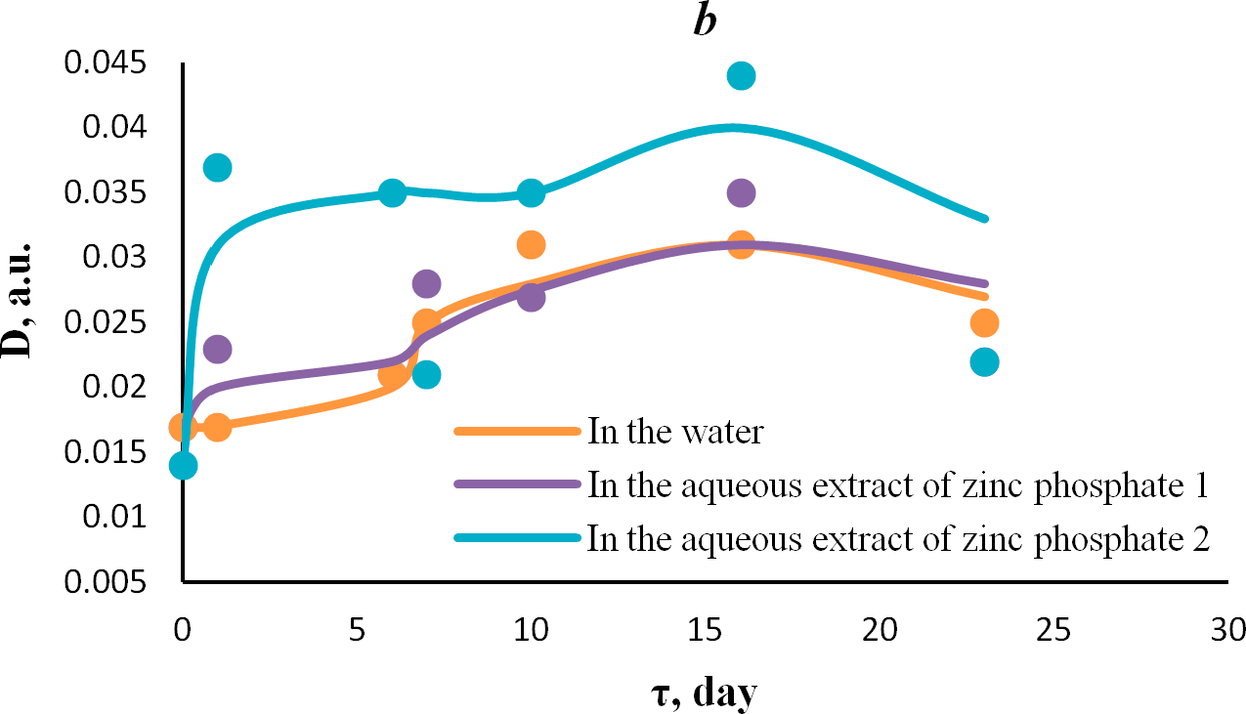

Figure 2. Dependence of the optical density of the dilute dispersion of PVA on time: in the resulting composition of PVA with the aqueous extract (*a*), that of the formed coatings (*b*).

PVA dispersion was also determined. It was evaluated by changing the optical density of the highly diluted dispersion in water and in the aqueous extracts of zinc phosphate.

As can be seen from Fig. 2, during storage of the resulting compositions, an extreme was observed in the dependence of their optical density on the exposure time. Moreover, the maximum on this curve (about 15 days) corresponds to the most dramatic change in the values of the surface energy of the coatings (Fig. 1).

The changes in the optical density indicate the beginning of the process of particle enlargement of the PVA dispersion with their further coagulation.

The films obtained were also studied by microscopy. It was found that during storage of the compositions obtained from the PVA dispersion and aqueous extract of zinc phosphate, the formation and increase in the amount of coagulum (large aggregates which can be seen in the micrographs) occur (Fig. 3). Moreover, this process correlates with an increase in the value of the surface energy of the coatings over time. Probably, anincrease in the surface energy of the coatings can also be caused by an increase in the content of micro-inhomogeneities in the film, which causes dispersion hysteresis of wetting.

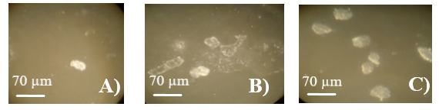

**Figure 3.** Micrographs of the coatings formed from the PVA dispersion and water extract of zinc phosphate **1** at different exposure times: 0 days (***a***); 16 days (***b***), 23 days (***c***).

**Conclusions**

Thus, the effect of zinc phosphate on the properties of water-dispersion materials during their storage and formation of the coatings was shown, which must be taken into account when developing them.

It was established that the water-soluble salts being present in the composition of zinc phosphate can have a negative effect on the aggregate stability of the aqueous dispersion of polyvinyl acetate, leading to the accumulation of coagulum during the material storage.

However, these changes do not result in the complete loss of the aggregative and sedimentation stability of the PVA dispersion and further research should be aimed at studying the effect of zinc phosphate on the performance properties of films formed from the PVA dispersion.

Corresponding author

* E-mail: svetvargasova@yandex.ru (S. V. Vargasova).

References

1. A. D. Yakovlev, *Chemistry and Technology of Paint Coatings*, KHIMIZDAT, St. Petersburg, **2008** (in Russian).

2. RU Patent 2572984, **2016**.

3. RU Patent 2460748, **2012**.

|  |  |
| --- | --- |
| This article is licensed under a Creative Commons Attribution-NonCommercial 4.0 International License. | [D:\Rinat\Rinat\доки\журнал\cc-by-nc.png](https://creativecommons.org/licenses/by/4.0/) |